Yossi Korazim-Kőrösy (DSW)
71 Yehuda HaYamit Str., Tel Aviv – Jaffa, Israel, 68035
Mobil/Cell: +972.50.6223027
yossikorazim@gmail.com

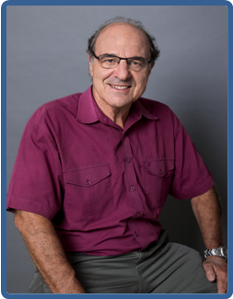
Yossi Korazim-Kőrösy is a professor at the John Wesley College, School of Social Work in Budapest (Hungary) and a senior lecturer at the Zefat Academic College (ZAC) in Israel.
He also teaches at the Graduate International Program of Tel Aviv University, School of Public Health and the Academic College of Tel-Aviv – Yaffo. His courses are on Social Welfare & Social Policy, Community Organizing, and Inter-organizational and Interdisciplinary Collaborations. At ZAC, he is heading the Interdisciplinary Research Center for Multi-Cultural Community Development.
As a private organizational and community consultant, he works for the Ministry of Social Affairs in Israel, where his last Public Sector position was the Head of Policy-Planning Department. Among other tasks, he was coordinating the Prime Minister's (Interdisciplinary) National Committee for Children and Youth At-Risk, and the National Reform Committee of the Local Social Welfare system.
Dr. Korazim-Kőrösy was the Founder and first Chair of the Interdisciplinary Forum for Community Development in Israel.
Born in Hungary, Dr. Korazim-Kőrösy served on the Boards of the International Association for Community Development (IACD) and the (American) Association for Community Organization and Social Administration (ACOSA). Previously, he served on the boards of the Israeli Association of Social Workers as National Chairman of Social Policy; Shatil – The New Israel Fund’s capacity building center for social change organizations and; Ossim Shalom – Social Workers for Peace and Welfare.
Dr. Korazim-Kőrösy holds a Bachelor of Social Work (BSW) and Master of Public Administration (MPH) from the Hebrew University, Jerusalem, and Doctor of Social Work (DSW) from Columbia University, NYC. Among his current international research interests are: Comparative Interdisciplinary Collaborations; Government – Civil Society Relations, and Macro-Practice methods for social change.
Dr. Korazim-Kőrösy has over 100 scientific publications and public documents in Hebrew, English and Hungarian.

