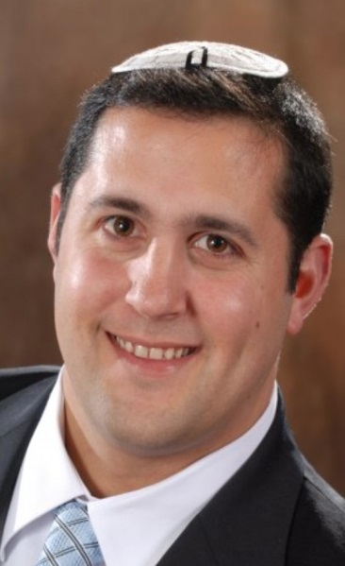
BIOGRAPHY
Raphael Herbst

International Relations Department

Director Resource Development

Senior Paramedic and Instructor
Magen David Adom

Raphael Herbst, 40, is a senior paramedic and instructor at Magen David Adom. For 25 years, he treated patients out of MDA’s Jerusalem Region and now works out of the organization’s headquarters in Tel Aviv.

Herbst was born in Rehovot and began his career with MDA as a 15-year-old youth volunteer. Since then, he has become an integral part of MDA’s world-class training program, instructing and mentoring incoming first-responders and serving as team leader for MDA’s Mobile Intensive Care Units ambulances.

Over the course of his career, Herbst has responded to many high-profile emergencies and terror attacks.

In addition to his work in the field as a paramedic, Herbst works in MDA’s International Relations Department. As an IDF soldier, he was a lieutenant colonel in the Home Front Command as a district population officer. Herbst is also an active volunteer member of the emergency and security committee for the local community leadership of Har Homa in Jerusalem.

Herbst holds a bachelor’s degree in business administration and a master’s degree in disaster management from Ben Gurion University. He is married with four children.

Contact information
raphaelh@mda.org.il

