Ido Rosenblat, EMT-P, MHA
Chief Information Officer
Magen David Adom, Israel
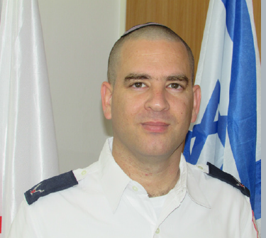
idor@mda.org.il

About the Role

The Chief Information Officer (CIO) monitors people, processes, and IT technologies within the organization to ensure that they deliver results that support the business objectives.
As digital becomes basic, the Chief Information Officer plays a key role in critical strategic, strategic and managerial tasks - from information security and algorithms to customer experience and data leverage - that mitigate threats and increase the range of opportunities and opportunities of the organization.

Fields of Responsibility

- Responsibility for implementation of infrastructure tender and tender for outsourcing of information systems.

- Management of the development team that serves the organization's systems according to the policy

- Responsibility for development progress in accordance with the required objectives

- Responsibility for characterizing the needs of all systems required according to the needs of the organization.

- Responsibility for the organization's system, including blood services

- Responsibility for all hardware progress in MDA, in the area of ​​information systems.

- Responsibility for adapting the operational system according to the needs of the organization.

- Responsibility for implementing the ISO standard in information systems.

- The organization's guidance in these computing tools (software, hardware, communications), will be purchased for the needs

- Organization.

- Responsibility for long-term planning of the organization's information systems.

- Determining procedures for monitoring and ensuring the integrity and confidentiality of computerized information.

- Responsibility for maintaining an adequate level of information technology in the organization.

- Responsibility for the integration of all administrative, professional and operational information systems.

Professional Highlights

Mr. Ido Rosenblat, B.A, MHA, EMT-P is a senior and airborne Paramedic.
In his previous position, Ido was responsible for all emergency dispatch units of Magen David Adom, including responsibility for training all the employees of the dispatch units, quality controls, writing work procedures and technologies.
he has created innovative technical solutions to improve the organization’s already legendary response time to emergencies, and created training courses and established qualifications criteria for the organization’s paramedics and EMTs. Previously, he was project manager, solution architect, and manager of the national integrated dispatch center, the precursor to the current dispatch system
Ido is one of the architects of the C&C system in the organization today, and accompanies the development of the system from its first day.
In 2019 ido was being one of six people honored by Israel tech magazin at its Chief Information Officer of the Year Awards
The award carries additional prestige in a country like Israel that’s renown for its high-tech startups.

Mr. Rosenblat has an associate’s degree in emergency medicine from the School of Paramedics in Ramat Gan, a bachelor’s degree (BA) in health systems management from Ariel Academic College in Ariel, a master’s degree (MHA) in health systems management and public health from Bar-Ilan University in Ramat Gan, and a law degree (LLB) from Ono Academic College in Kiryat Ono.

