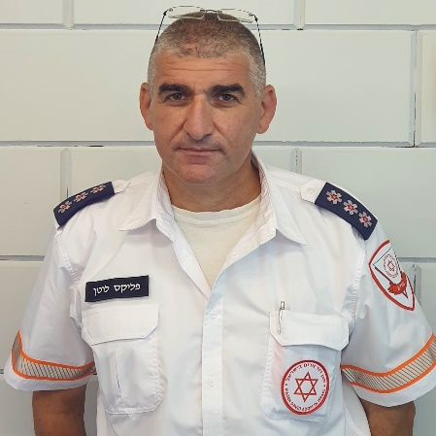
Felix Lotan
felixlo@mda.org.il

Education | M.EM Emergency medicine, Ben Gurion University  Paramedic Diploma, Magen David Adom  B.A. History, Hebrew University  Teaching Diploma, Hebrew University  2002 EMT Diploma | 2017  2009  2004  2004  2002
Employment | Deputy Manager Emergency management department, Magen David Adom (Israeli national EMS ) | 2004-current
- Deputy Manager Jerusalem regain
- Paramedic Supervisor
- Paramedic on MICU in Jerusalem
- EMT –P instructor
- Earthquake preparedness coordinator
 | Diving Industry | 1997-2011
- ERDI Public Safety Diving instructor
- Course director for NAUI, ACUC & Instructor certifier for SSI
- TDI TriMix Instructor
- Teaching materials development and translation
- Diving gear technician and technical lab manager
 | Education | 2003-2005
- History teacher 10th- 11th grade
- Outdoor activities instructor & coordinator 8th-12th grade
Military, IDF | 1990-1997 Mandatory army service; 1997- Current reserve army service (lieutenant colonel)
 | - Chief operation officer medical department HFC
 | - Medical officer Israeli National Search and rescue unit
 | - Search and rescue officers
Volunteer | Fire department
 | - Team leader Search & rescue water activity unit | 2009-2012
 | - Manager of an First Responder Medical team in Mevasseret Ziyon
Languages | Hebrew – mother tongue  English – fluent  Russian – fluent (conversation)

